**A Click Above, LLC Presents**

**Theory and Problem-Solving Obedience Seminar**

**with Connie Cleveland**

**July 12th and 13th 2025**

**About the seminar:**

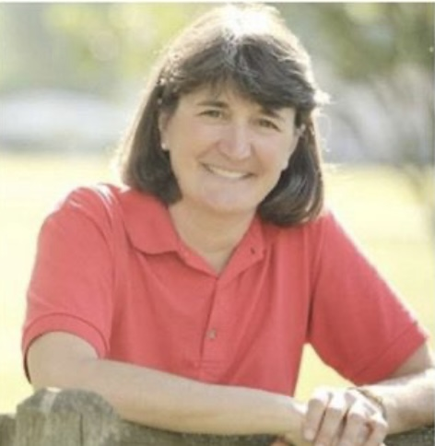Connie’s two-day seminars focus on understanding all levels of competitive obedience. The seminar will begin with a discussion on how dogs learn. Then Connie spends time working individually with each working team. Generally, day one focuses on individuals working on attention, heeling, retrieving, and recalls. On Day 2, Connie will help teams with more difficult exercises such as go-outs, articles, drop on recall, etc.

**About Connie Cleveland**: Connie Cleveland-Nolan is an internationally recognized dog trainer who has been teaching and coaching dog obedience students for over three decades. In 2019, Connie launched *The Obedience Road,* a complete online resource for obedience competitors. Utilizing written and video content, monthly webinars, community forums, and personalized video review, Connie coaches newcomers and experienced competitors alike.

Connie competes in both Obedience and Retriever Field Trials, having finished 12 Obedience Trial Champions (OTCH), two Field Champions (FC), five Amateur Field Champions (AFC), a UDT Maltese, and a CDX Shih-Tzu.

**Seminar Details:**

Saturday July 12-- 9 a.m. to 5 p.m. and Sunday July 13 – 8 a.m. to 4 p.m.

Light snacks and water will be provided each day. Lunch will not be provided.

The seminar will be held at the A Click Above facility located at 19277 Evergreen Mills Rd, Leesburg, Va, 20175. The facility is an indoor, climate-controlled building with artificial turf footing.

**Working Spot- 2 days (limit 20 dogs):** Current ACA students $250; General Public $275

**Auditing Spot (non-working):** Current ACA students $50/one day or $75/two days; General Public $70/one day or $105/two days

Full payment must be received with the registration form to reserve a spot in the seminar. **Please make checks payable to A Click Above.** No refunds will be given after June 1, unless your spot can be filled.

**Mail registrations to**: Nancy Walkins, 14258 Milltown Rd, Lovettsville, VA 20180

**For questions and information**, please contact Nancy Walkins at [hugak9@aol.com](mailto:hugak9@aol.com).

**Connie Cleveland Registration Form**

**Handler’s name______________________________________________**

**Address____________________________________________________**

**Phone #____________________________**

**Email__________________________________**

**Dog’s call name_________________________Breed___________ Age______**

**__________ACA Student Working ($250) _______Non-Student Working ($275)**

**__________ACA Student Audit 2 days($75) _______Non-Student 2 days ($105)**

**____________ACA Student audit 1 day($50) ________ Non-Student 1 day ($70)**

**Please complete the questionnaire and waiver and return it with your registration.**

**Seminar Questionnaire**

**Handler Name____________________________________________**

**Dog’s Call Name___________________________________________**

**Dog’s Breed__________________________________Dog Age______**

**Current Training level________________________________________**

**Have you attended one of Connie’s seminars before? ______________**

**Are you a member of Obedience Road?__________________________**

**What are your training goals?**

**What problems are you encountering?**

**Are there other issues that you would like addressed?**

Waiver for Events sponsored by A Click Above, LLC

1. Handlers must clean up after their dogs and dispose of the waste properly.
2. Dogs must be supervised by an owner/handler at all times.
3. Children under 18 years of age must be accompanied by an adult at all times. Children under the age of 15 must be directly supervised by an adult at all times. Children may not "entertain" themselves while class is in session or at any time on ACA grounds.
4. Equipment may not be used unless an instructor from A Click Above is present and/or teaching a class/lesson. Violation of this rule can/will result in dismissal from class/lesson.
5. Bitches in season may participate in lessons/seminars if the owner brings their own bedding and has bitch wear panties in the building at all times.
6. Students may park in designated areas only.
7. All dogs (except puppies too young to receive the vaccine) must be up to date on rabies vaccination and/or adequate titre. Owners must be able to show proof of rabies certificate or state letter of titre sufficiency.
8. Please clean up water, drool, or any other mess in any crates used.
9. Please note that indoor potty accidents incur a $25 fine, payable to ElMay associates.

Event Lesson Release Form

In consideration that I will be a participant in an A Click Above event, taught by Connie Cleveland-Nolan within the calendar year 2025, to be held at A Click Above’s rented Training Center (located at 19277 Evergreen Mill Road, Leesburg, VA, 20175, (property owned by Elsie Maylott and ElMay Associates) I hereby release owner of A Click Above, LLC (Claudia Bates), Connie Cleveland-Nolan, and any instructors or assistants employed by A Click Above, LLC from all liability in the event of injury to myself, my family members, spectators with me, other dogs as a result of my dog’s actions, or to my dog at any time on said property. In addition, I will agree to pay for any and all damages to the property of the A Click Above Training Center (Owned by Elsie Maylott and ElMay Associates) that is caused by me due to violation of A Click Above’s Operating Procedures. I have read and understand A Click Above’s Operating Policies as stated above and understand that violation of any or all policies can result in my dismissal (without refund) from class (at the discretion of class instructor).

_________________________________________________________(print name)

______________________________________________________________(signature